# CS 255 System Design Document Template

Steven Anderson

## UML Diagrams

### UML Use Case Diagram

### UML Activity Diagrams

UML sequence for courses and tests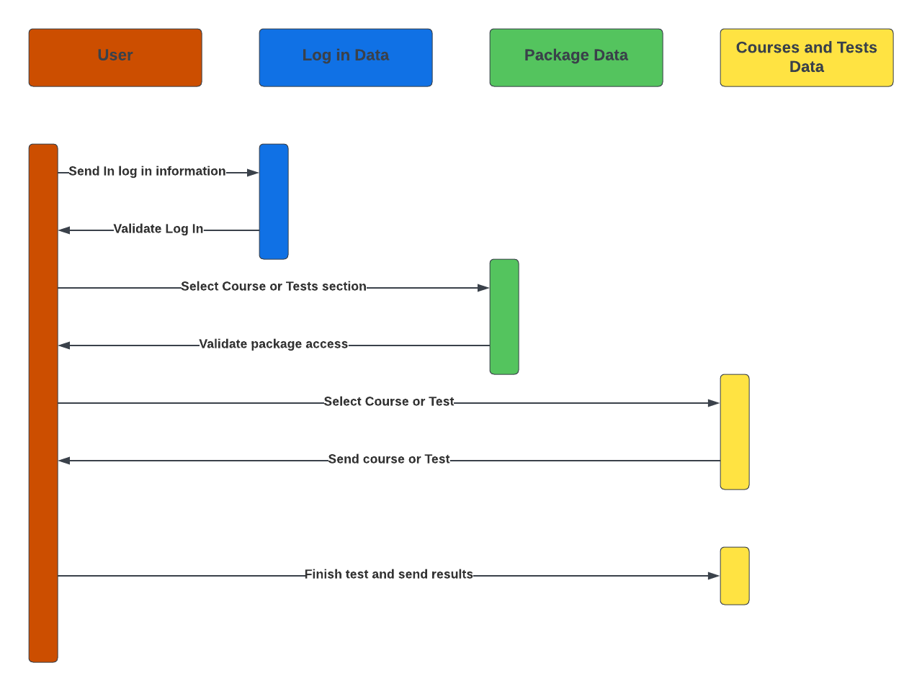

UML sequence for driving lesson scheduling 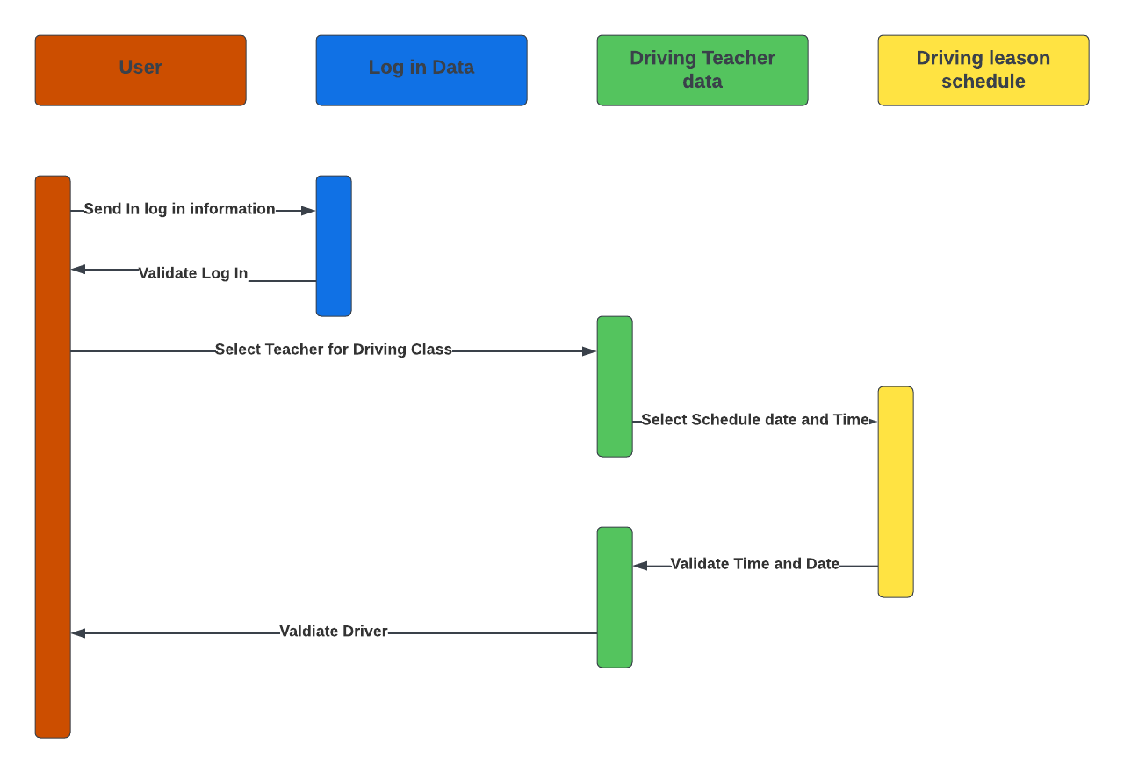

UML Activity for package select and pay, and UML activity for course and test access

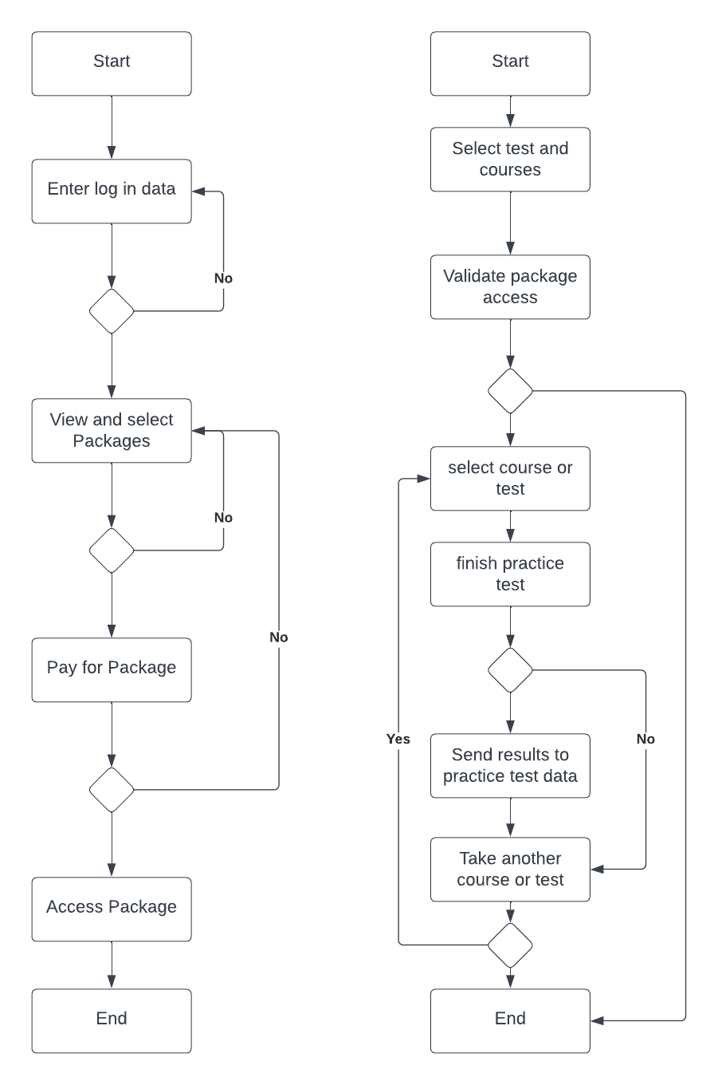

### UML Sequence Diagram

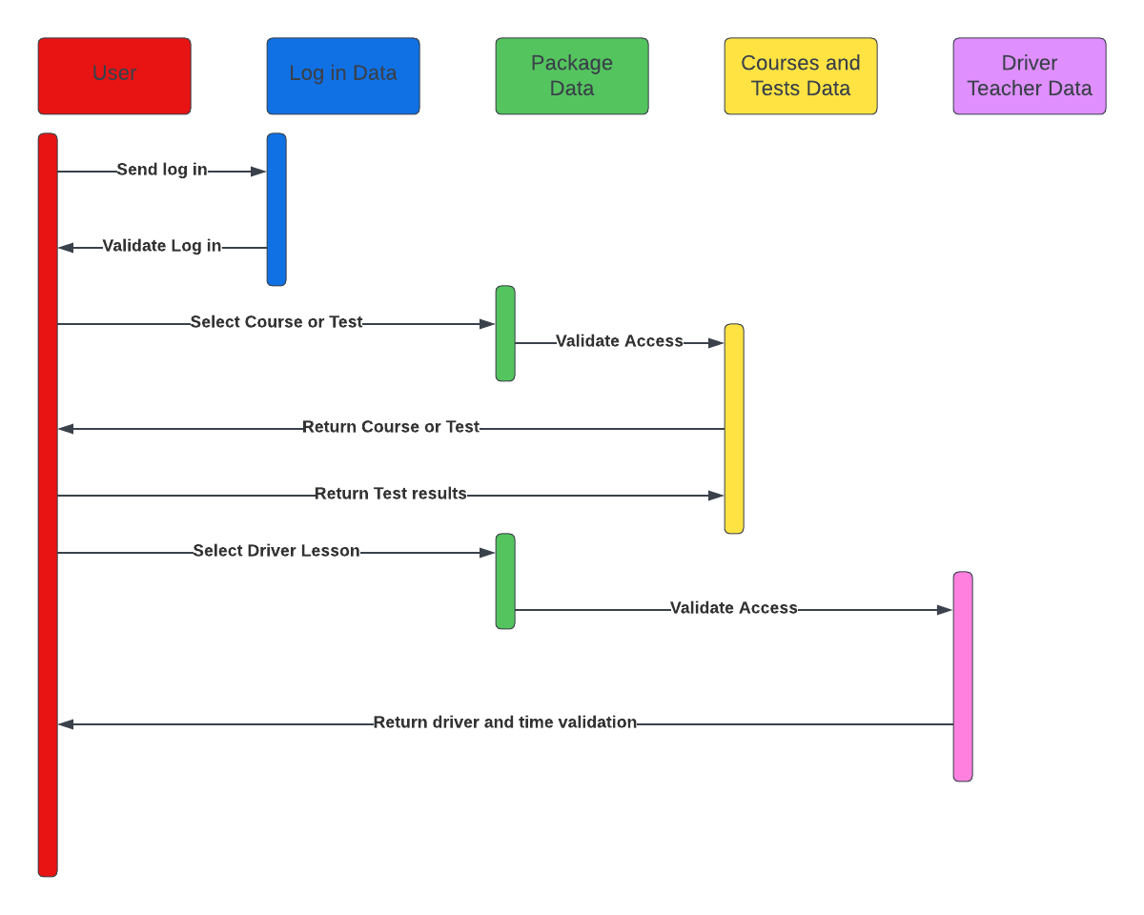

### UML Class Diagram

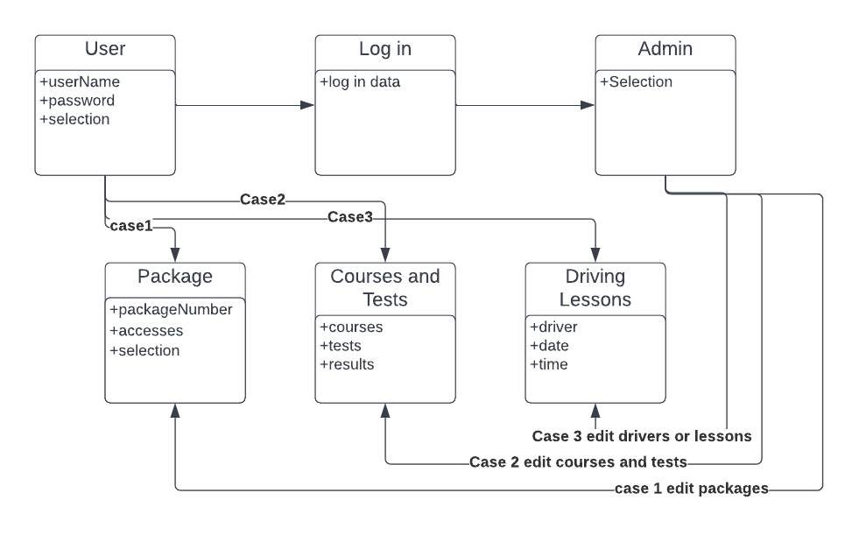

## Technical Requirements

For this project it will require a server to host the website. It can be done using Microsoft’s Azure system which hosts our server space necessary. It also allows us access to the Microsoft web security software that can be packaged with Azure. We also need to use some form of code development software like Visual Studio to create the program. Additionally, could be an HTML coding software/editor. We will also need to make sure we have a team large enough to cover for any problems that may arise. It will need developers, a team lead, and one or more testers.

The software itself will also need time to develop the user interface for ease of use. We also need to test for server strength and code speed to see webpage loading speeds. We also need to validate the SSL to ensure user information is secure both from the user and on the website’s server host. We should also make sure through testing that the webpage can be operated on a mobile platform. This could be done through checking the page’s responsiveness or by creating a mobile server version of the page.

This project’s purpose is to allow users access to driving school software and scheduling. We need to ensure the user can access the packages that the client offers. Then based off of that the need to be able to access the courses and practice tests and the driver scheduling. The scheduling needs to have the options of location, driver and date. We also need to allow the admin access through secure log in to editing of packages, courses, and driver schedules. We will also need a technician log in so that they can monitor the webpage health and debug when issues arise.